**You can do it!**

**RULES:** Practical Shooting Handbook, Latest Edition **COURSE DESIGNER:** Ike Starnes

|  |  |
| --- | --- |
| **START POSITION: See written stage briefings.** | |
| **STAGE PROCEDURE**  Engage targets from within the shooting area. | **SCORING**  **SCORING:** Comstock, 27 rounds, 135 points  **TARGETS:** 12 cardboard targets, 3 rubber targets  **SCORED HITS:** 2 Best hits per carboard will be scored, rubber must fall to score  **START-STOP:**  Audible - Last shot  **PENALTIES:** Mike -10, NS -10, Procedural -10 |

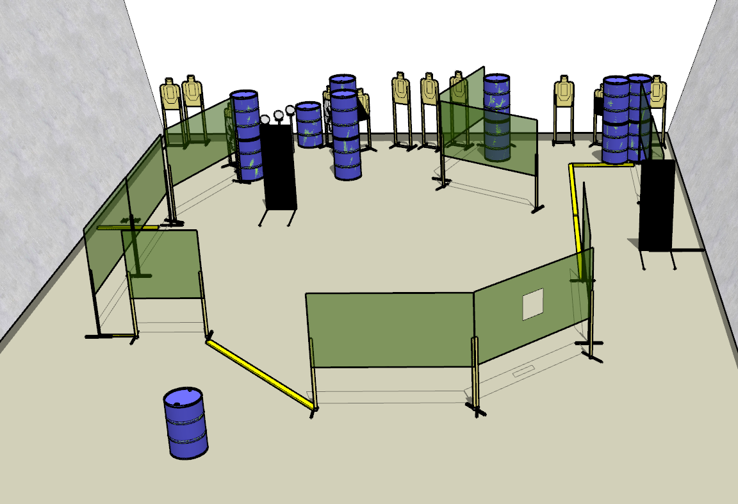

**Written Stage Briefings:**

**Stage 1 –** is a 27-round, 135 point, Comstock Long Course. There are 12 cardboard targets and 3 rubber targets. The best 2 hits per cardboard target will be scored, the rubber targets must fall to score.

**Handgun start position** is standing with both feet on the Xs with wrists below belt. The handgun is loaded and holstered.

**PCC start position** is standing with both feed on the Xs, PCC is loaded with safety on and buttstock on belt with muzzle pointed downrange.

On the audible start signal, engage targets from within the shooting area.

**Stage 3 –** is a 27-round, 135 point, Comstock Long Course. There are 12 cardboard targets and 3 rubber targets. The best 2 hits per cardboard target will be scored, the rubber targets must fall to score.

**Handgun start position** is standing with toes of both feet on the right, forward fault line with wrists above respective shoulders. The handgun is loaded and holstered.

**PCC start position** is standing with toes of both feet on the right, forward fault line with strong hand wrist above respective shoulder. PCC is loaded with buttstock on belt, safety on, and muzzle pointed downrange.

On the audible start signal, engage targets from within the shooting area.

**Stage 1 –** is a 27-round, 135 point, Comstock Long Course. There are 12 cardboard targets and 3 rubber targets. The best 2 hits per cardboard target will be scored, the rubber targets must fall to score.

**Start position** is standing near the barrel with both hands flat on top of barrel. Gun is unloaded and unpropped on the barrel with muzzle pointing downrange.

All magazines and reloading devices must come from the belt (pockets).

On the audible start signal, engage targets from within the shooting area.